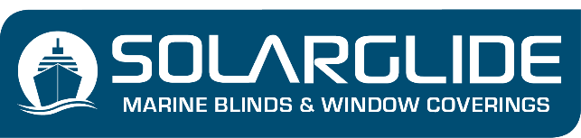
CURTAINS ENQUIRY FORM
See NOTES on page 2 for assistance completing the below table. Email to theteam@solarglide.com once complete

Item | Location/ Window Ref | Qty | Track Width | Curtain Height  *TOP OF CURTAIN TRACK TO FLOOR | Single or split pair | Fullness % | Header Style | Fabric Choice  Name / code or supplier | Fabric Colour | Lined  Y/N | Lining colour | Tie Backs Y/N | Track  Y/N | Track Fittings  Y/N
1 |  |  | mm | mm
2 |  |  | mm | mm
3 |  |  | mm | mm
4 |  |  | mm | mm
5 |  |  | mm | mm
6 |  |  | mm | mm
7 |  |  | mm | mm
8 |  |  | mm | mm
9 |  |  | mm | mm
10 |  |  | mm | mm
11 |  |  | mm | mm
12 |  |  | mm | mm
13 |  |  | mm | mm
14 |  |  | mm | mm
15 |  |  | mm | mm
16 |  |  | mm | mm
17 |  |  | mm | mm
18 |  |  | mm | mm
19 |  |  | mm | mm
20 |  |  | mm | mm
21 |  |  | mm | mm
22 |  |  | mm | mm
23 |  |  | mm | mm
24 |  |  | mm | mm

NOTES:
Header Styles: Choose from 1. Pencil Pleat 2. Double Pinch Pleat 3. Triple Pinch Pleat 4. Wave
Fullness %: The greater the amount of material, the more depth and luxury created.
Our recommended Fullness for standard ship windows is 200% fullness.
For maximum luxury we would recommend 300% fullness
We would not recommend a fullness under 150% as aesthetically it won’t look great on the window.
For bunkbed curtains 100% fullness is accepted
Fabric Choice: If a material and fabric supplier has been specified by yourself or a designer, add this to the table above. Solarglide will be able to source this fabric on your behalf from our network of fabric suppliers. If you are unsure of the fabric that you would like, please refer to the colour section on the curtain’s product page via the website www.solarglide.com . If there is nothing on there that fits with your requirements, contact our team and we will create a mood board based on your desired texture, colour, pattern, or thickness.
Curtain Tracks and fixtures:
Solarglide offer a multitude of tracks, which are cut to size and assembled so they can be fixed straight into position when onboard. Our range includes standard, bracket-less, curved, large length, and double tracks
The term ‘track’ refers to the curtain track (also known as the headrail or curtain rail)
Solarglide tracks are supplied with a powder coated white finish as standard. Alternative track colours are available upon request
Backing Lining:
Some curtain fabrics don’t require a backing lining, however Solarglide would always recommend them for making your curtain the best it can be.
Backing lining add depth, thickness and luxury to a curtain, and this additional thickness always creates a better look when the curtains are hung in position.
Fittings and Fixtures:
Solarglide supply tracks, brackets, hooks, tie off hooks, tie backs and screws.

