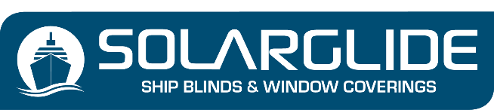
BLACKOUT SCREEN ENQUIRY FORM
Company Name
Contact Name
Telephone Number
Email Address
Vessel Name or project Name
Product Type
(Manual Cassetted, Manual Non Cassetted, Motorised or Solar Powered)

PREFERRED MECHANISM (Mark with an ‘X’)

- Sidewinder Chain with Cable Guides
- Centrepull Handle with Level Pegs
- Centrepull with Sidechannels & Locking Device
- Centrepull with Sidechannels (Set at multi levels on the window)
- Double Pulley system with Cable Guides
- Single Pulley system with Cable Guides
- Centrepull with Leather Straps and Buckle (1 or 2 strap solutions)
- We do other bespoke operating systems, if your desired mechanism is not specified write your requirements below:

STATE YOUR DESIRED COLOUR OF FABRIC

STATE YOUR PREFERRED BLACKOUT FABRIC (Mark with an ‘X’)

DART FABRIC (75% PVC & 25% Fibreglass)
CARVINAL FABRIC (100% Polyester)

DO YOU REQUIRE 100% BLACKOUT (Mark with an ‘X’)

YES
NO

PROFILE COLOURS – CASSETTE, BOTTOM RAIL, SIDECHANNELS (Mark with an ‘X’)

Standard Colours: No additional Charge

Light Grey
White

An additional Charge is added for a unique powder coated RAL colour choice:

RAL COLOUR OF CHOICE SPECIFY HERE
NOTE: SIDECHANNELS CAN ONLY BE USED ON RECTANGULAR OR SQUARE WINDOWS

Item | Qty | Window  Ref | Cass’  Width | Bottom  Rail Width | Shape | LHT | RHT | Drop
1
2
3
4
5
6
7
8
9
10
11
12
13
14
15
16
17
18
19
20
21
22
23
24
25
26
27
28
29
30
31
32
33
34
35
36

Send to theteam@solarglide.com

