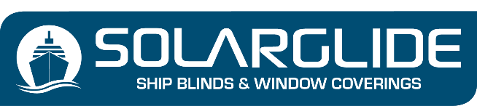
SUSTAINABLE SCREEN ENQUIRY FORM
Company Name
Contact Name
Telephone Number
Email Address
Vessel Name or project Name

PREFERRED MECHANISM (Mark with an ‘X’)

- Sidewinder Chain with Cable Guides
- Centrepull Handle with Level Pegs
- Centrepull with Sidechannels & Locking Device
- Centrepull with Sidechannels (Set at multi levels on the window)
- Double Pulley system with Cable Guides
- Single Pulley system with Cable Guides
- Centrepull with Leather Straps and Buckle (1 or 2 strap solutions)
- Motorised and hardwired to ships power supply
- Battery Operated with micro solar panel
- We do other bespoke operating systems, if your desired mechanism is not specified write your requirements below:

STATE YOUR DESIRED COLOUR OF FABRIC (Mark with an ‘X’)

White
Avenida Grey
Plaza Grey
Pebble
Calle Grey
Rambla Grey
Kaina Blue

PROFILE COLOURS – CASSETTE, BOTTOM RAIL, SIDECHANNELS (Mark with an ‘X’)

Standard Colours: No additional Charge

Light Grey
White

An additional Charge is added for a unique powder coated RAL colour choice:

RAL COLOUR OF CHOICE SPECIFY HERE

NOTE: SIDECHANNELS CAN ONLY BE USED ON RECTANGULAR OR SQUARE WINDOWS

Item | Qty | Window  Ref | Cass’  Width | Bottom  Rail Width | Shape | LHT | RHT | Drop
1
2
3
4
5
6
7
8
9
10
11
12
13
14
15
16
17
18
19
20
21
22
23
24
25
26
27
28
29
30
31
32
33
34
35
36

Send to theteam@solarglide.com

