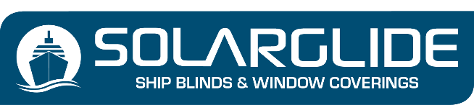
DUAL 24 TWIN ROLLER ENQUIRY FORM
Company Name
Contact Name
Telephone Number
Email Address
Vessel Name or project Name

PREFERRED MECHANISM (Mark with an ‘X’)

- Dual sidewinder chain with cable guides (One control LEFT / One control RIGHT)
- Dual sidewinder chain with cable guides (Both controls LEFT)
- Dual sidewinder chain with cable guides (Both control RIGHT)
- Dual double pulley system (without cable guides)
- Dual double pulley system (with cable guides)

STATE YOUR PREFERRED FABRIC CHOICES (Mark with an ‘X’) TICK TWO CHOICES

DART BLACKOUT FABRIC
CARVINAL BLACKOUT FABRIC
ROE DIMOUT FABRIC
CARVINAL DIMOUT FABRIC
SOLAR FILM
SUSTAIN ‘RECYCLED OCEAN PLASTIC’ DIMOUT FABRIC

STATE YOUR DESIRED COLOUR OF FABRIC – See colour collection on Twin Roller webpage

COLOUR CHOICE 1
COLOUR CHOICE 2

PROFILE COLOURS – CASSETTE, BOTTOM RAIL, SIDECHANNELS (Mark with an ‘X’)

Standard Colours: No additional Charge

Light Grey
White
Own specified RAL colour

OPTIONAL: If you want a different PROFILE colour to white or light grey, an additional charge is added for a unique powder coated RAL colour choice:

RAL COLOUR OF CHOICE SPECIFY HERE

Add your window dimensions here:

Item | Qty | Window  Ref | Cass’  Width | Bottom  Rail Width | Shape | LHT | RHT | Drop
1
2
3
4
5
6
7
8
9
10
11
12
13
14
15
16
17
18
19
20
21
22
23
24
25
26
27
28
29
30
31
32
33
34
35
36

Send to theteam@solarglide.com

